|  |  |
| --- | --- |
| **DATE** | 15 November 2022 |
| **TEAM ID** | PNT2022TMID26051 |
| **PROJECT NAME** | Smart crop protection system for agriculture |

CREATE NODE-RED SERVICE

STEP 1: Install node.js

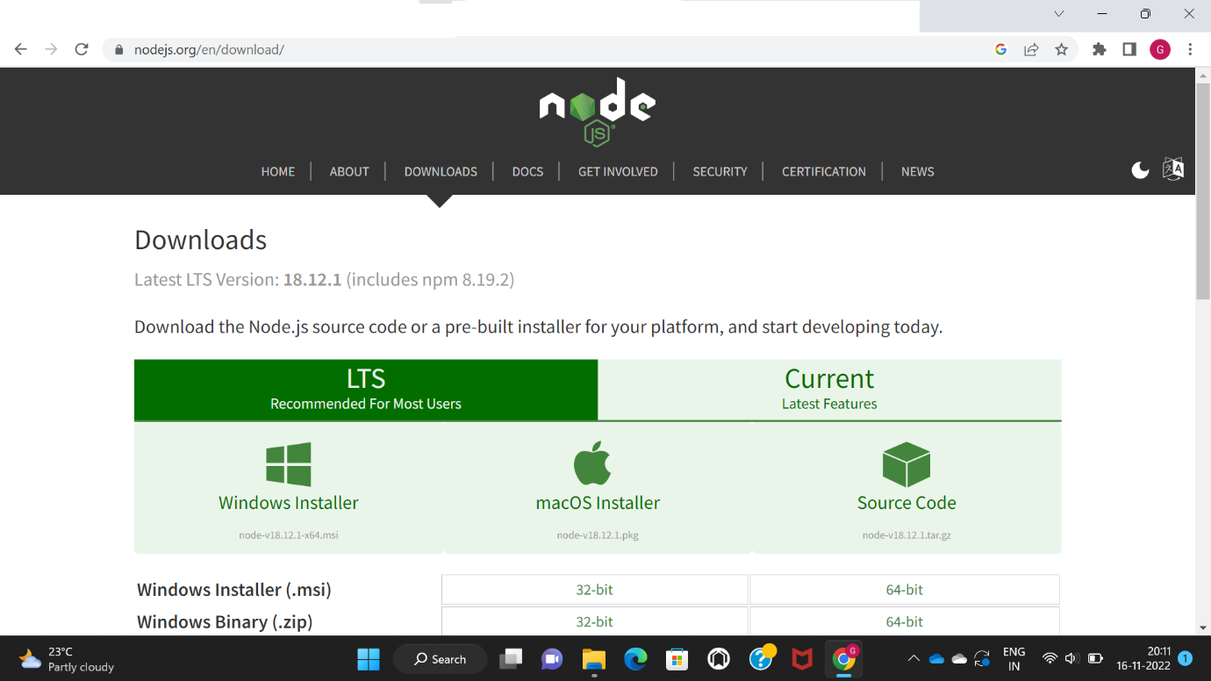

STEP 2: Next open command terminal

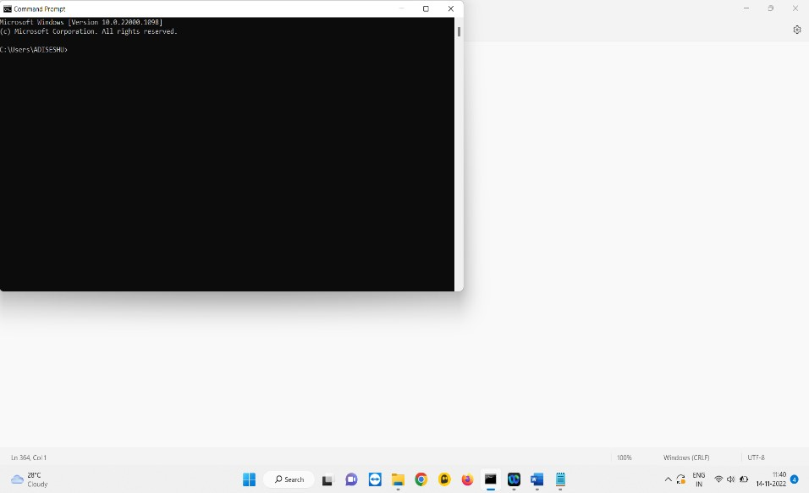

STEP 3: Type npm install -g –unsafe-perm node-red.

This command downloads the local service of node-red in the machine

STEP4: After installation we need to check the node-red service, for that type “node-red”.

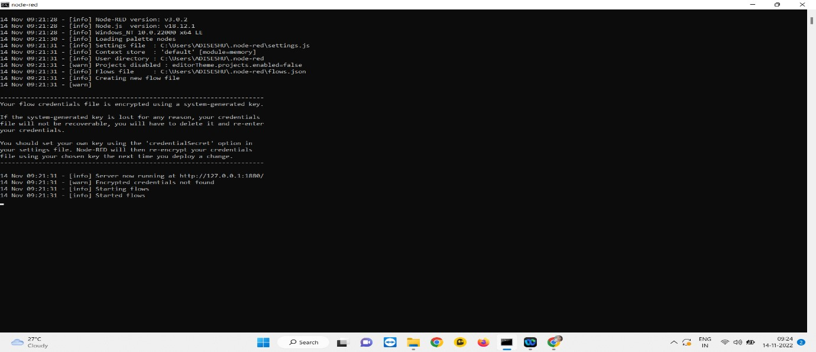

STEP5: Then we can see a URL like ”http:// 127.0.0.1:1880”, this link redirects to the local node-red service.

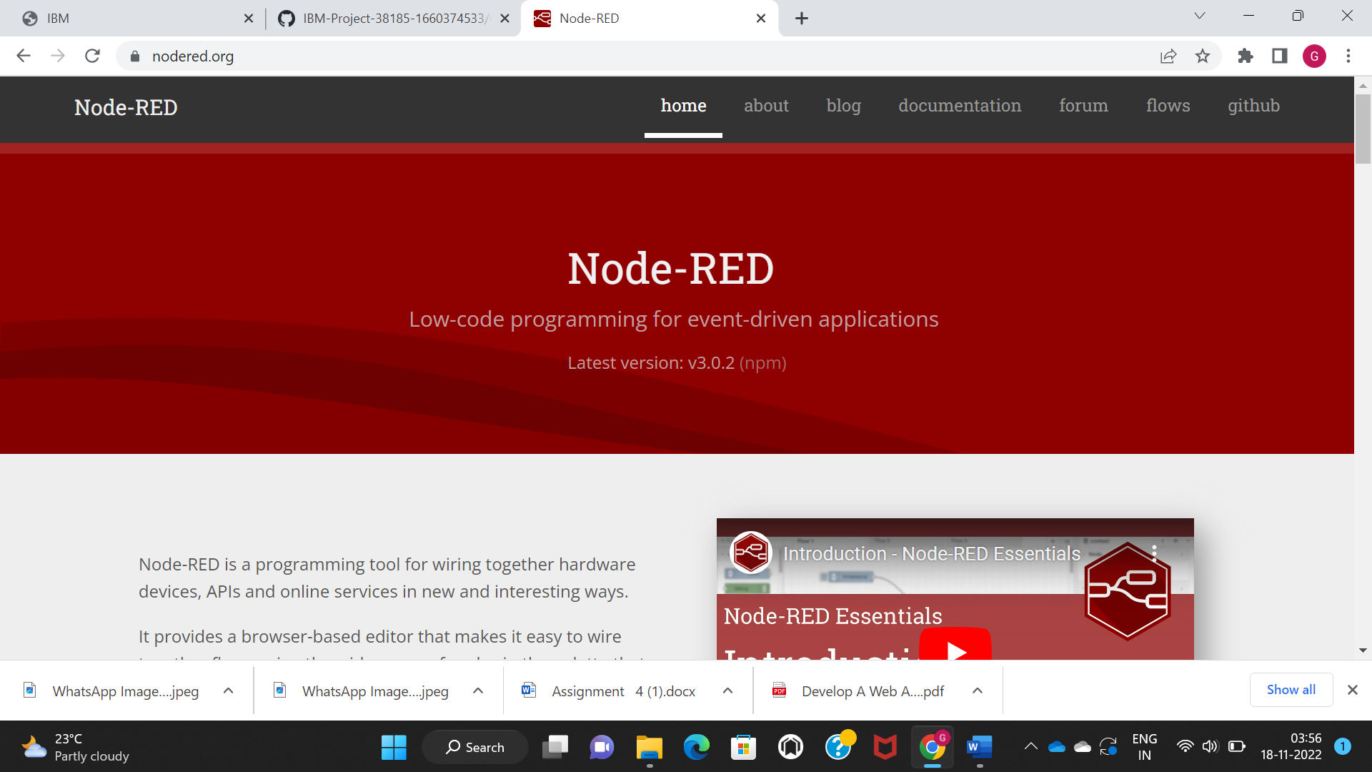

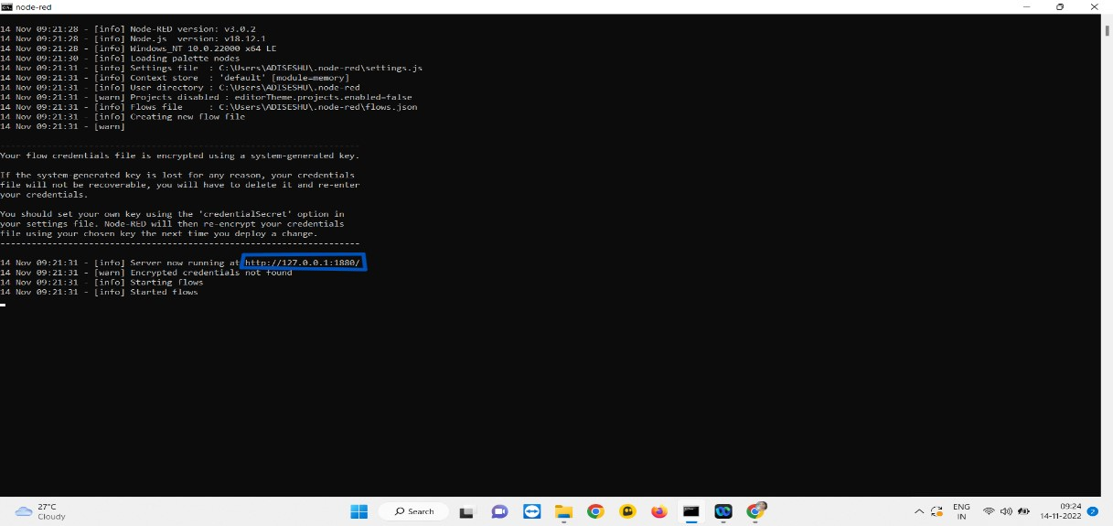

STEP 6: The node- red will open

